**Assignment 3: Branching and Merging**

1. **Create a new branch**:
   * In GitHub Desktop, click "**Current Branch**" > "**New Branch**."  
     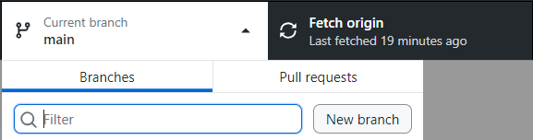
   * Name it **feature/add-styles** and click "**Create Branch**."  
     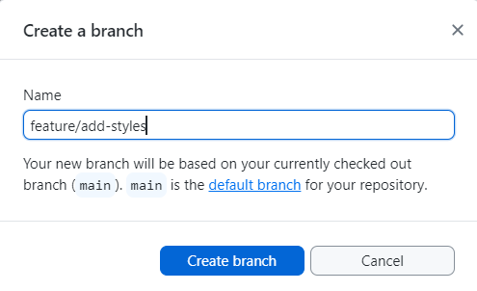
2. **Add styles.css**:
   * Create a **new file** named **styles.css** in your repository folder and add the following code:

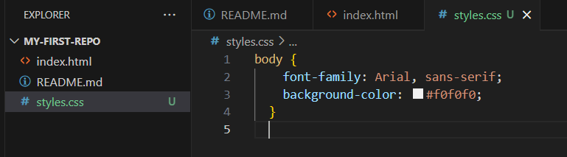

* + Link it to **index.html** by adding this line inside the **<head> tag**:

<link rel="stylesheet" href="styles.css">

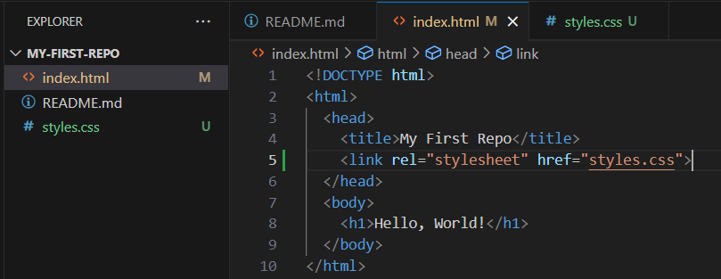

1. **Commit and push**:
   * Stage the changes, write a **commit message**, e.g., "**Add styles.css**."  
     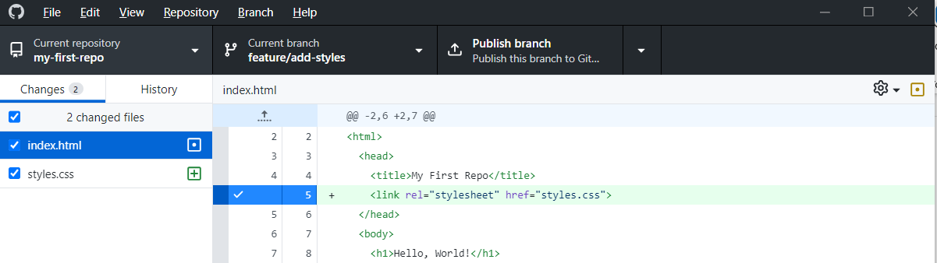
   * Click "Commit to **feature/add-styles**" and then "**Push origin**."  
     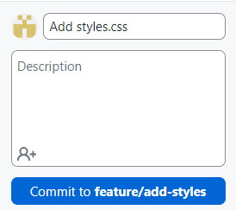  
     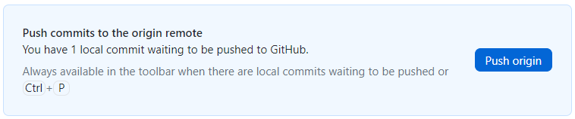  
     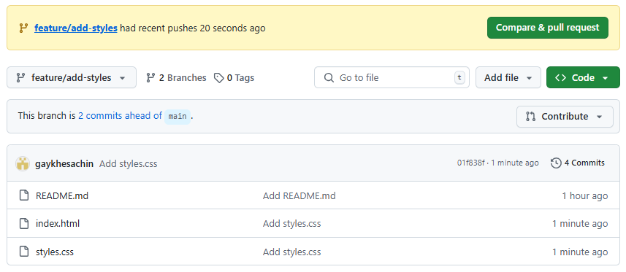
2. **Merge into main**:
   * Switch back to the main branch.  
     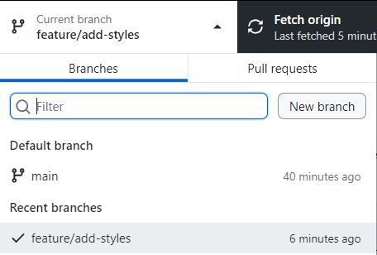
   * Click "**Branch**" > "**Merge into Current Branch**."  
     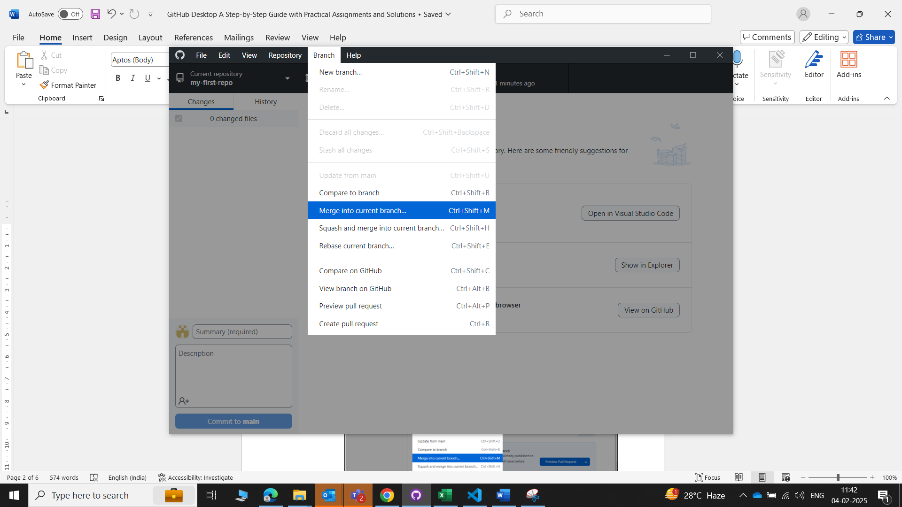
   * Select **feature/add-styles** and click "**Merge**."  
     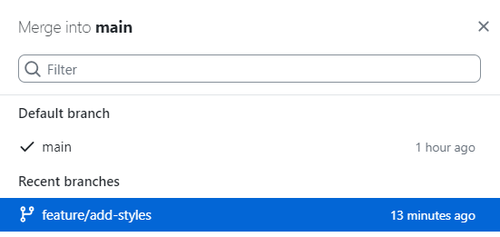  
     
   * **Push** the changes to the remote repository.  
     